A Project Report

On

**“ONLINE FOOD DELIVERY SYSTEM”**

*For the partial fulfillment of the requirement of 4th semester of*

Masters of Computer Application

of

Jorhat Engineering College

Affiliated To Dibrugarh University, Assam



Submitted By

**Trinayan Sankar Das**

MCA 4th Semester

Roll - MCA 19/16

**Zyandeep Baruah**

MCA 4th Semester

Roll - MCA 03/16

Under the guidance and supervision of:

**Mr. Abhinash Borah**

Assistant Professor

Department of MCA

Jorhat Engineering College

**JORHAT ENGINEERING COLLEGE**



**CERTIFICATE**

This is to certify that the project titled **“ ONLINE FOOD DELIVERY SYSTEM ”** is a bonafide work, carried out by Trinayan Sankar Das and Zayndeep Baruah of MCA 4th semester for the partial fulfillment of the requirement for the Master of Computer Application.

I wish both of them all success in future.

**Mr. Joydip Sarmah**

HOD, Dept. of Computer Application

Jorhat Engineering College

**JORHAT ENGINEERING COLLEGE**



**CERTIFICATE**

This is to certify that the project titled **“ONLINE FOOD DELIVERY SYSTEM ”** is a bonafide work, carried out by Trinayan Sankar Das and Zayandeep Baruah of MCA 4th semester for the partial fulfillment of the requirement for the Master of Computer Application.

I wish both of them all success in future.

**Mr. DhrubajyotiBaruah**

Assistant Professor,

Dept. of Computer Application

Jorhat Engineering College

**JORHAT ENGINEERING COLLEGE**



**CERTIFICATE**

This is to certify that the project titled **“ ONLINE FOOD DELIVERY SYSTEM ”** is a bonafide work, carried out by Trinayan Sankar Das and Zayandeep Baruah of MCA 4th semester for the partial fulfillment of the requirement for the Master of Computer Application.

I wish both of them all success in future.

**Mr. Abhinash Borah**

Assistant Professor,

Dept. of Computer Application

Jorhat Engineering College

**ACKNOWLEDGEMENT**

We take this opportunity to express our sincere thanks and gratitude to our project guide **Mr. Dhrubajyoti Baruah and Mr. Abhinash Borah** who motivated, encouraged and helped us to ensure that this project,

**“ ONLINE FOOD DELIVERY SYSTEM ”** reached the stage of completion.

We also express our honest salutation and gratitude to **Mr. Joydip Sarmah**, HOD, Dept Of Computer Application, Jorhat Engineering College for the help and cooperation for successful completion of the project.

With due regards.

Your's Sincerely,

**Trinayan Sankar Das**

MCA 4th Semester

Roll - MCA 19/16

**Zyandeep Baruah**

MCA 4th Semester

Roll - MCA 03/16

**DECLARATION**

We hereby declare that the project entitled **“ ONLINE FOOD DELIVERY SYSTEM ”** has been carried out by us and the contents have been submitted to the Department of Computer Application, for the partial fulfillment of the 4th semester of Masters of Computer Applications.

**Trinayan Sankar Das**

MCA 4th Semester

Roll - MCA 19/16

**Zyandeep Baruah**

MCA 4th Semester

Roll - MCA 03/16

**PROJECT OUTLINE**

* Title of the Project: “ONLINE FOOD DELIVERY SYSTEM”
* Aim of the Project: Manage the details of Food item, Sales of food item & Calculate per day collection.
* Purpose: 4th Semester Minor Project.
* Duration of the Project: 4 Months Approximately
* Project Done By: Trinayan Sankar Das (MCA-19/16) Zyandeep Baruah (MCA-03/16)

Guided By:

**Mr. Abhinash Borah**

Assistant Professor

Department of MCA

Jorhat Engineering College

**CHAPTER 1**

**INTRODUCTION**

**1.1 INTRODUCTION**

The main aim of the project is the management of the database of a small fast food shop. This project is insight into the design and implementation of a Online Food Delivery System of a small fast food shop.

This is done by creating a database of the available food item in a specific fast food shop. The primary aim of **online food delivery system** is to improve accuracy and enhance safety and efficiency in a specific fast food shop. The aim of this project is to develop software for the effective management of a fast food shop.

**Online food delivery system** is useful to maintain correct database by providing an option to update the available food item. This is online food delivery system; it is used to manage most fast food shop related activities in the fast food shop.

**1.2 PROBLEM DEFINITON :**

This phase is usually performed by the system analyst under a preliminary investigation. The problem must be stated clearly, understood and agreed upon by the user and the analyst. They examine the functioning of each unit before deciding specific areas in which the computerization may be most useful. Besides this they also ascertain the weakness of the present system.

The objective of this phase is to obtain the necessary information out of the existing system and design phases.

* Determine objectives of current system.
* Study current system to see how far it meet its current objectives.
* Analyse user’s requirements to develop new objectives.
* Identify user’s responsibility of data input and output to other system.
* Examine interaction of proposed system with other system.

**1.2 THE PROPOSED SYSTEM**

The proposed system is an electronic method through which the manual process of handling and processing problems is done by the computer system. The proposed system is mainly designed to overcome the problems of the existing system. The proposed system is also easy to manage, modify and maintain.

Some of the advantages of the proposed system :

* Reduces data redundancy
* Provide updated information
* Efficient, easy to use, less error prone.

The proposed system has been developed for a specific small fast food shop. In this system the food items of that fast food shop will be available online and the administrator of the system can monitor the sell information and per day collection of food items.

In our proposed system there are two types of users :

**Admin:**

Admin performs the following task-

* Add food items.
* Update & Disapproved food items.
* Add today’s special item.
* View Customer info.
* Approve customer’s order.
* View the bill of the customer’s order.
* Approve the bill’s paid status
* View per day collection of all order in a particular day.

**Customer:**

Customer performs the following task

* Customers make their own profile.
* Update their profile.
* Browse all available items.
* Buy/ Order items.
* Cancel order.
* View bill of the order.

**1.4 OBJECTIVE OF THE PROPOSED SYSTEM**

The main objective of the project is :

* To provide users with an user friendly web application to buy food items at ease.
* To computerize ordering food items to manage data, so that all transactions become faster. It replaces all the paper work. Computerizing the system will solve many errors that arise due to manual operation done with pen and paper like calculation mistake, bill generation etc
* To maintain a computerised database of food items and customers.
* User can also cancel their order.

**1.5 SCOPE OF THE PROPOSED SYSTEM**

* Save time and effort.
* Enhance data security.
* Proper maintenance of data.
* Unauthorized users cannot use the system as it is password protected.
* Faster searching.
* Easier navigation.
* Help maintain data at ease
* Reduce clerical efforts
* Enable easy access to information when required

**1.4 HARDWARE AND SOFTWARE USED**

**HARDWARE USED:**

* Processor : Intel Pentium Dual Core
* RAM : 4 GB
* HDD : 500 GB
* Keyboard and Mouse

**SOFTWARE USED:**

* Operating System : Windows 8.1,Linux
* Front-End : HTML5, CSS3, jQuery,bootstrap4
* Back-End : PHP7, MySQL

The Project has been done using Relational Database Management System (RDBMS).

**CHAPTER 2**

**FEASIBILITY STUDY**

**2.1 INTODUCTION**

The main aim of the feasibility study activity is to determine whether it would be financially and technically feasible to develop the product. The feasibility study activity involves the analysis of the problem and collection of all relevant information relating to the product such as the different data items which would be input to the system, the processing required to be carried out on these data, the output data required to be produced by the system as well as various constraints on the behavior of the system.

There are three key considerations involved in the feasibility analysis. They are:

* Economic Feasibility
* Technical Feasibility
* Behavioral Feasibility

**2.2 ECONOMIC FEASIBILITY**

In economic Feasibility, which is also known as cost benefit analysis, benefit expected from the candidate system is compared with cost. If the benefit out weights cost, then the decision is made to design and implement the system. Otherwise, further justification or alteration in the proposed system will have to be made.

**2.3 TECHNICAL FEASIBILTY**

Technical Feasibility centers around the existing system (hardware, software etc.) and to what extend it can support the proposed system. The study here involves financial consideration too, in order to accommodate technical enhancement. Technically, the development of the system is feasible since all the resources required for the development of the proposed system are easily available.

.

**2.4 BEHAVIORAL FEASIBILITY**

In general, people resistant to change and computer have been known to facilitate change. A survey should be made of how strong a reaction the user staff is likely to have towards the development of computerized system.

As more and more people are purchasing PC with internet facilities, the attitude towards the candidate system seems to be positive. Moreover an easy, unambiguous, attractive GUI will attract more and more people towards the system that is being built.

**2.5 CONCLUSION**

From the observation made in the feasibility study described above, it was recommended that proposed system is completely feasible for its development and implementation.

CHAPTER 3

STRUCTURED ANALYSIS

**3.1 INTRODUCTION**

One of the best approaches to system analysis is the structured analysis. The structured analysis is a set of techniques and graphical tools that allows to develop a system specification that is east to understand to the developers. It is the detail step-by-step investigation of related procedures to see what must be done and to determine the best way of doing it. The objective is to build system specification that provides the basis for design and implementation.

The common tools adopted in system analysis are :

* Data Flow Diagram
* Entity Relationship Diagram
* Data Dictionary

**3.2 DATA FLOW DIAGRAM (DFD)**

A data flow diagram is a graphical tool, which has the purpose of clarifying system requirements and identifying major transformations that will become programs in the system design. A DFD consists of a series of bubbles joined by the lines. The bubbles represent data transformations and lines represent data flows in the system. It depicts the information flow and transformation that occurs as data moves from input to output. The DFD provides a mechanism for functional modeling as well as information flow modeling.

The following diagrams illustrate notations and symbols used to construct DFD:-

A source (originator) or destination of system data i.e. the user.

A process

Data in flow

Data Storage

Report or Outputs from the system

The data flow diagrams constructed in this project are as follows:

**DFD Of Online Food Delivery System**

Response

Request

**Admin**

Request

Response

**User/Customer**

0-Level DFD

**DFD Of Online Food Delivery System**

Request for login

**Admin**

Response accept/reject

Check for item details

Item manage

(add,update,disapproved)

**Item**

Response

Response accept/reject

Check for order details Request for view order

Request for view order

**Order**

Response accept/reject

Response

Check for payment details

Request for view payment

Response accept/reject

Response

**Bill**

Check for payment details

Request for view report

1st Level DFD of Admin

Response accept/reject

Generate report for order & details

1st Level DFD of Customer

**Customer**

Response

Response accept/reject

Check for show item

**Item**

Show item

Request for registration

Check for registration

Response accept/reject

Response

**Customer**

Check for login

Response

Request for login

Response accept/reject

Check for customer details

Profile Manage

(add.update)

Response accept/reject

Response

Request for food order

Check for order details

**Order**

Response

Response accept/reject

Check for cart

Request for add to cart

Response

Response accept/reject

Checkt for unique order id

Request for unique order id

Response

Response accept/reject

Response

Check for payment

**Bill**

Request for payment

Response accept/reject

**3.3 ER DIAGRAM:**

**Symbols used in E R Diagrams**

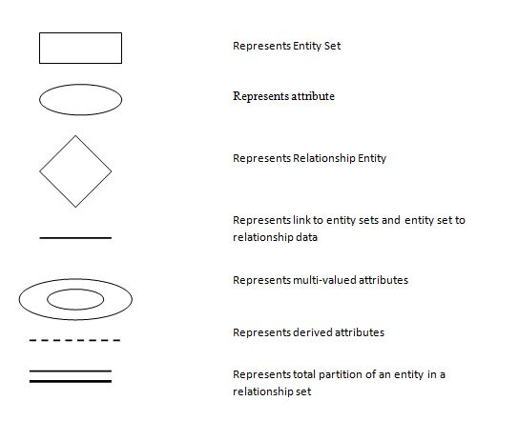

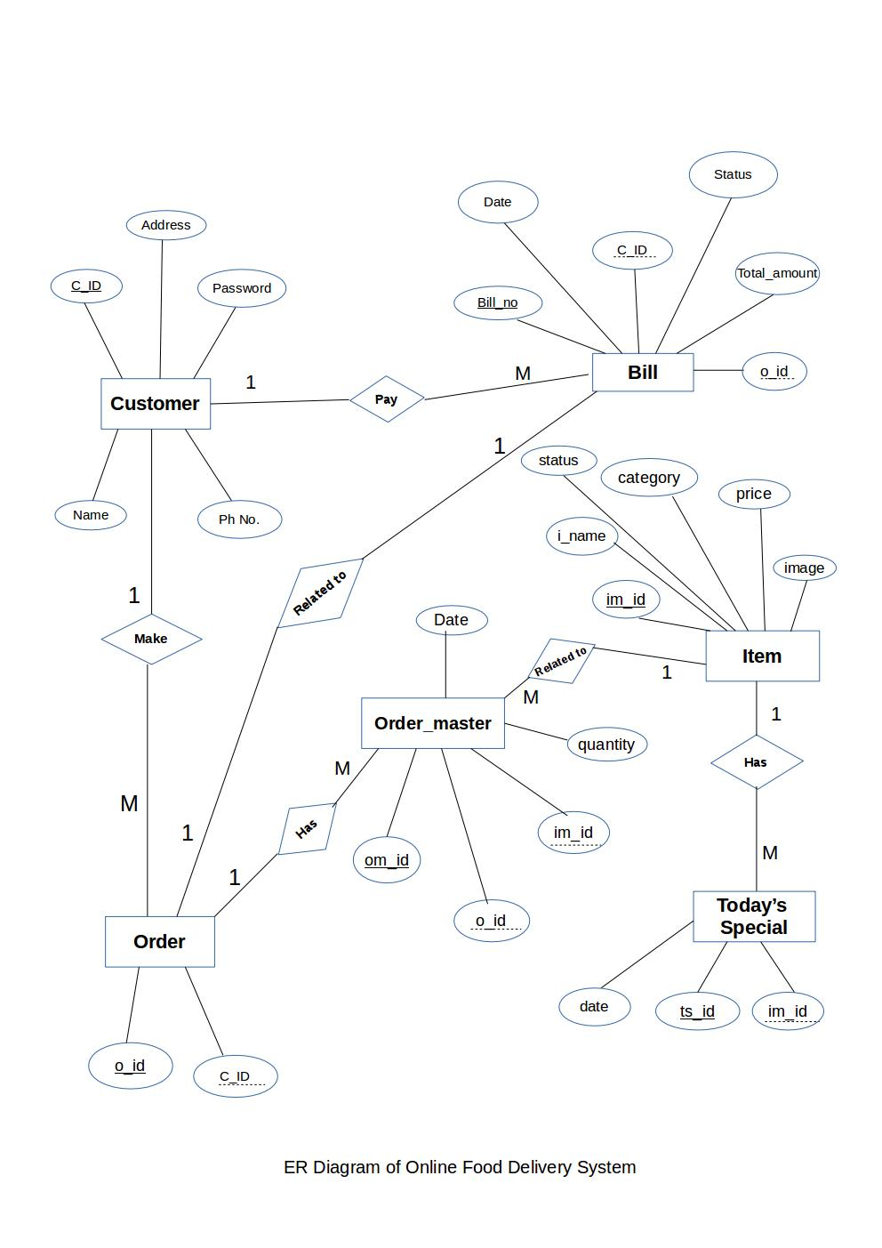**3.4 DATA DICTIONARY**

**Admin table:**

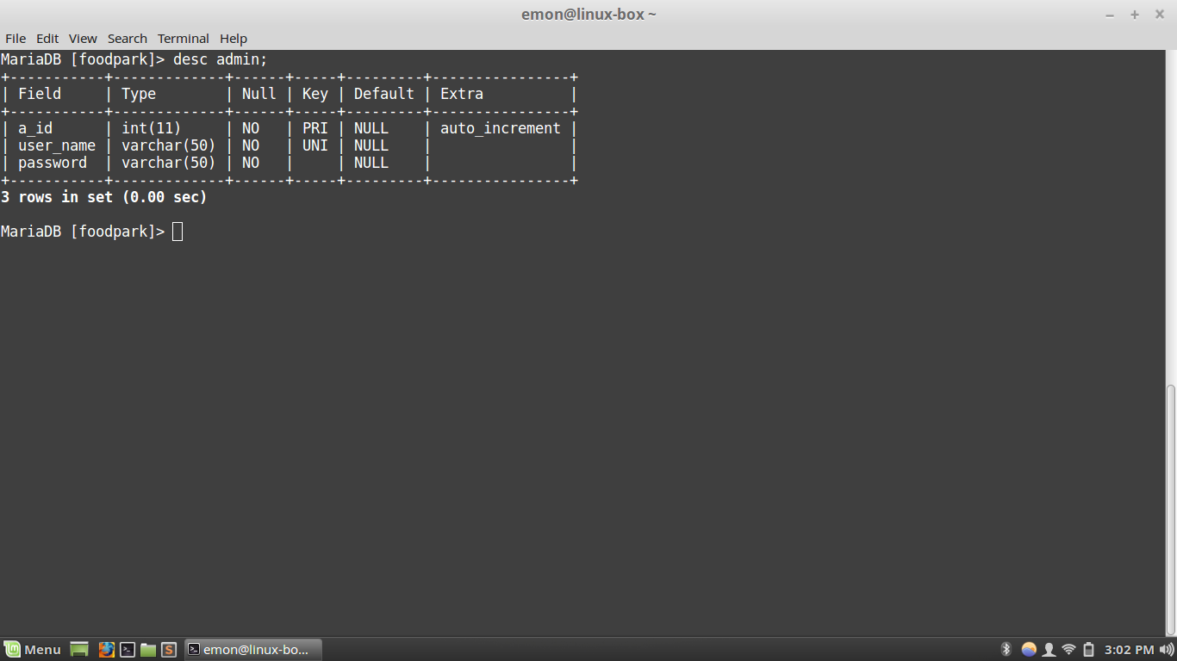

**Customer table:**

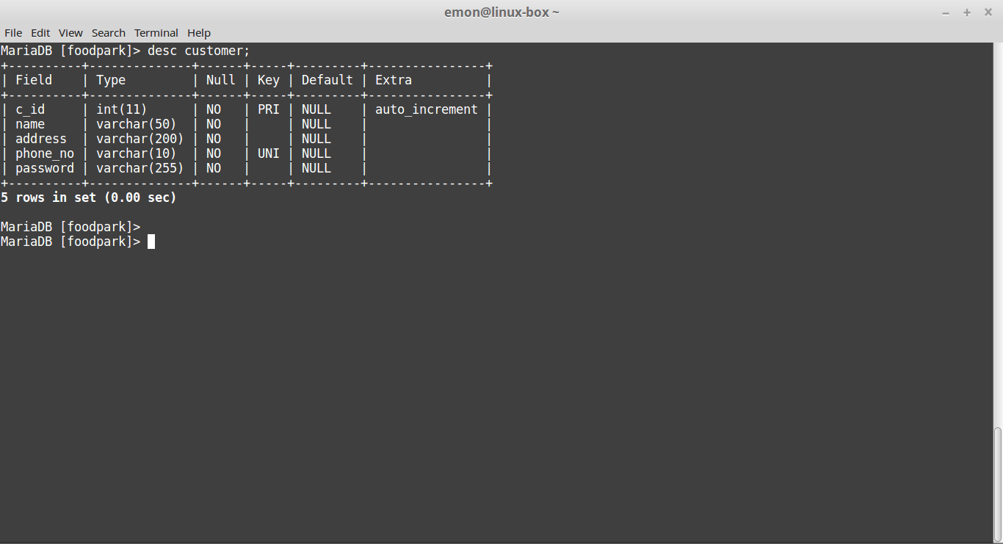

**Item Table:**

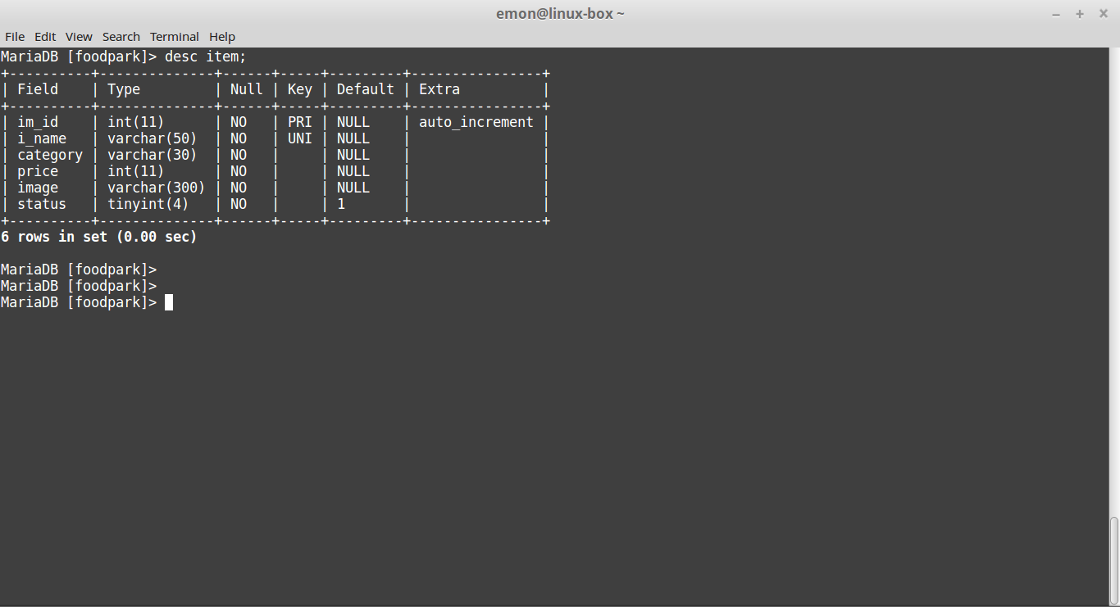

**Order Table:**

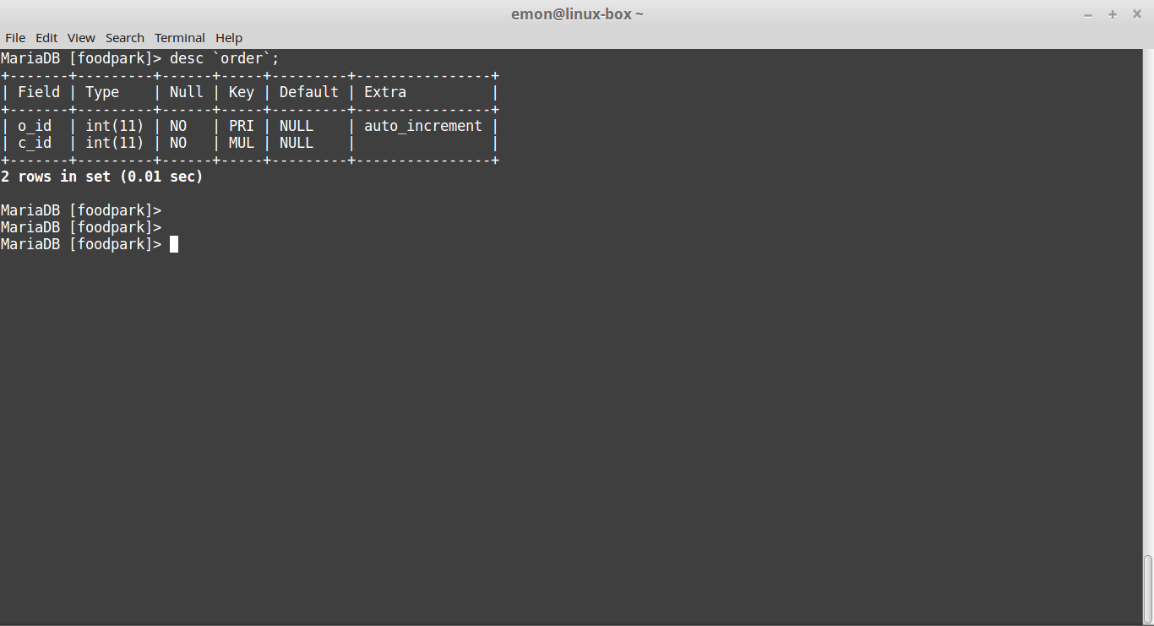

**Order_master Table:**

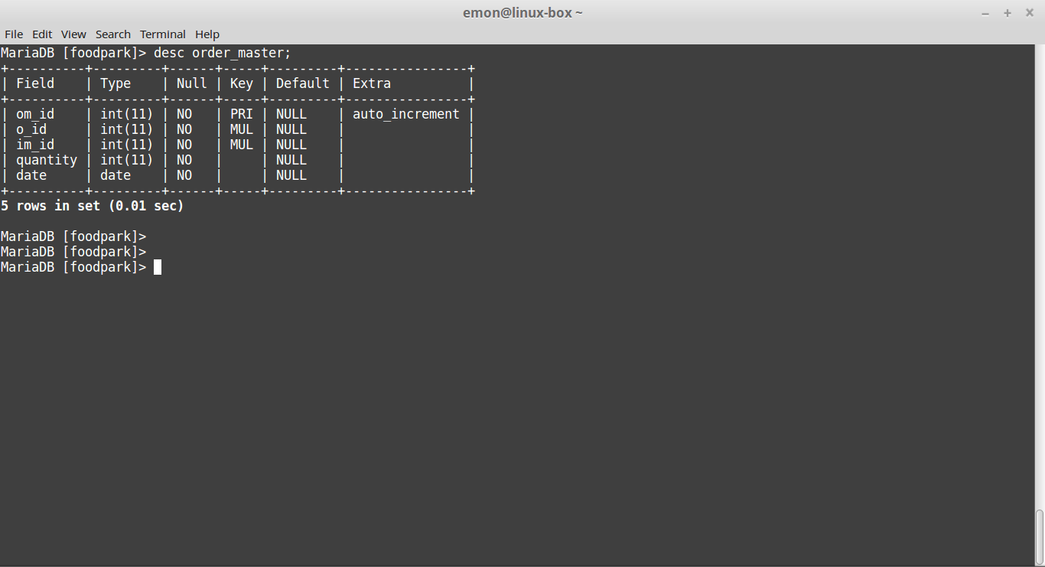

**Today’s_special Table:**

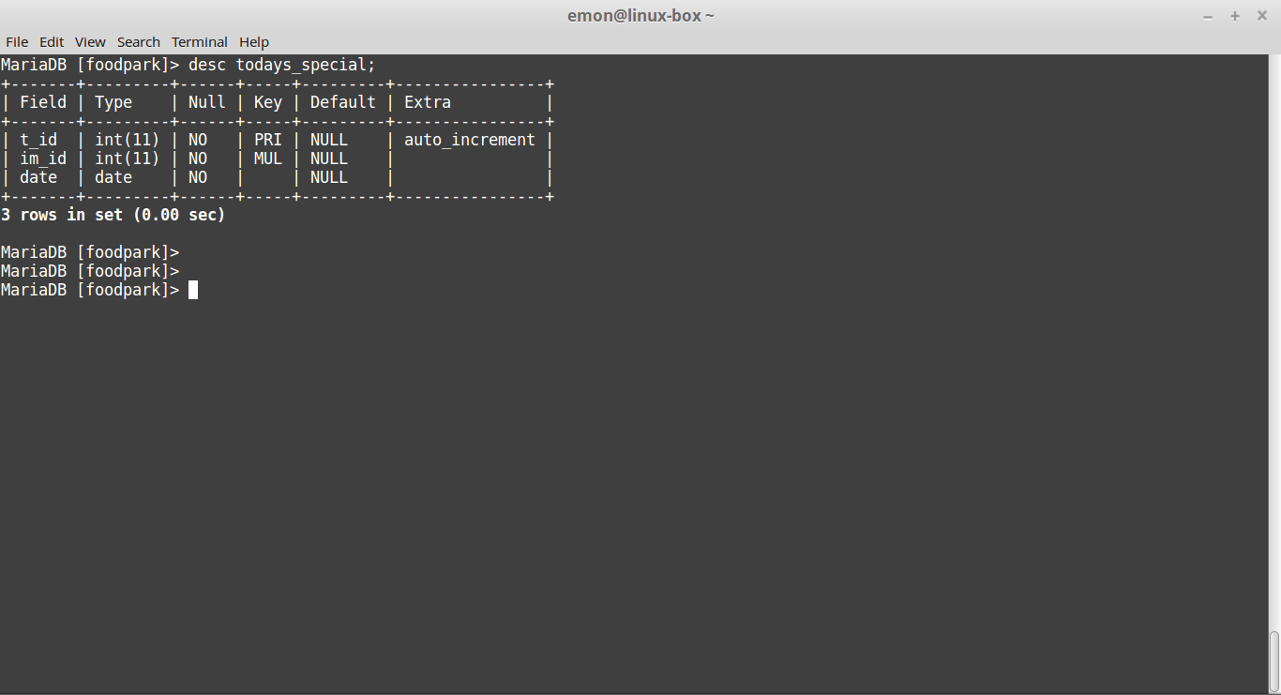

CHAPTER 4

SYSTEM DESIGN

**4.1 INTRODUCTION**

This important phase is composed of several steps. It provides understanding and procedural details necessary for implementing the system recommended in the feasibility study.

**4.2 DESIGN STRATEGY**

The design strategy is the vital aspect of the system to be developed. The system design is essentially a blueprint or a plan for a solution for the system. The design of the system describes the final system and processes by which it is developed. It refers to the technical specifications that will be applied in implementing the system. It also includes the construction of the program testing. The goal of the design process is to produce a model or representation of a system, which can be used later to build that system. The product made is called the design of the system.

While designing a the new system one has to consider many factors. These factors include the drawbacks and limitations of the present system as well as proposed features and the advantages of the system. It should be designed in a such a way that a person with limited knowledge can use it without any difficulty, i.e. the system should be user friendly. The design of the system should be such that a little change made in the system should not affect the entire system.

**4.3 TYPES OF DESIGN**

**4.3.1 LOGICAL DESIGN**

Logical design specify the users need at a level of details that virtually determines the information flow in and out of the system and the required data resources. Logical design describes the inputs, outputs, databases and procedures all in a format which meets the users requirements.

**4.3.2 PHYSICAL DESIGN**

It provides the working system and defines the design specification that tells the programmers exactly what the candidate system must do. In short, it can state that physical design is the implementation of the logical design. Physical system design consists of the following steps :

Design the physical system.

Specify the input/output media.

Design the database and specify backup procedures.

Design physical information flow through the system and a physical design walkthrough.

**4.3.3. INPUT DESIGN**

Input design is a crucial part of any system design. Inaccurate input data are common cause of errors in data processing. Data entry errors can be controlled by input design. Input design is the process of converting user-oriented input to computer-based format. The goal of designing input data is to make data entry as easy, logical and free from errors as much as possible.

**4.3.4 OUTPUT DESIGN**

Computer output is the direct source of information to the users. Efficient output design would improve the system relationship with the user and help in design making. In the system under consideration, the output is in two forms – hard copy from the printer and output to the screen in the predefined format.

**4.3.5 DATABASE DESIGN**

Usually, a collection of interrelated data is referred to as a database. The database contains information about one particular enterprise. Database system is designed to manage large volumes of information. The management of data involves both the definition structures of the storage of information and provision for manipulating information. In addition, the database system must provide data security.

**4.3.6 FORM DESIGN**

A form is the physical carrier of data. It can carry authority for action. In designing a form, attention is given to proper identification and wording, composition and layout, order of data items and clarity of instructions.

**4.3.7 Screenshot Of Project**

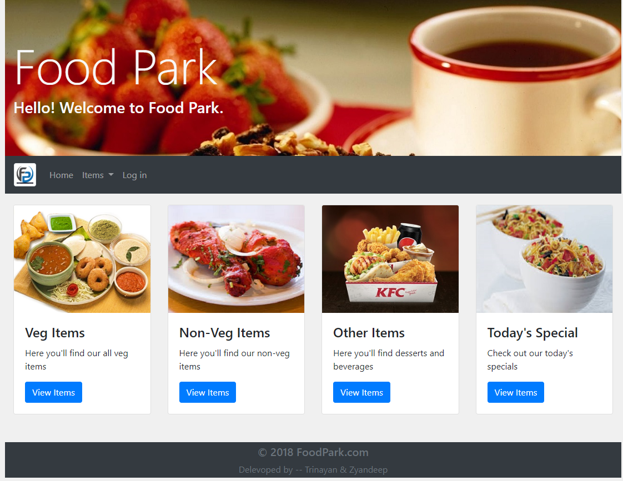 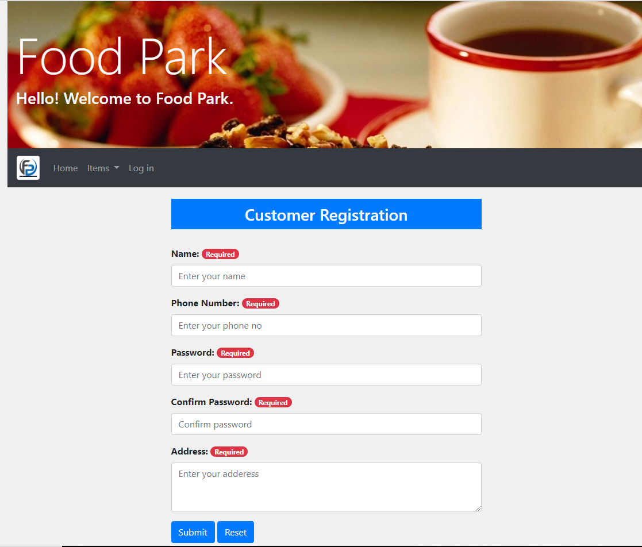

**HOME PAGE**

**Customer Registration**

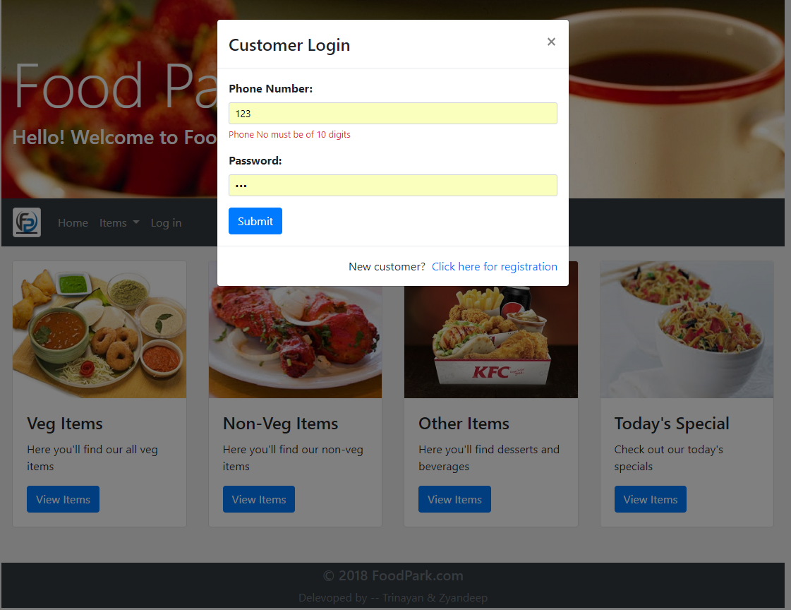

**Customer Login**

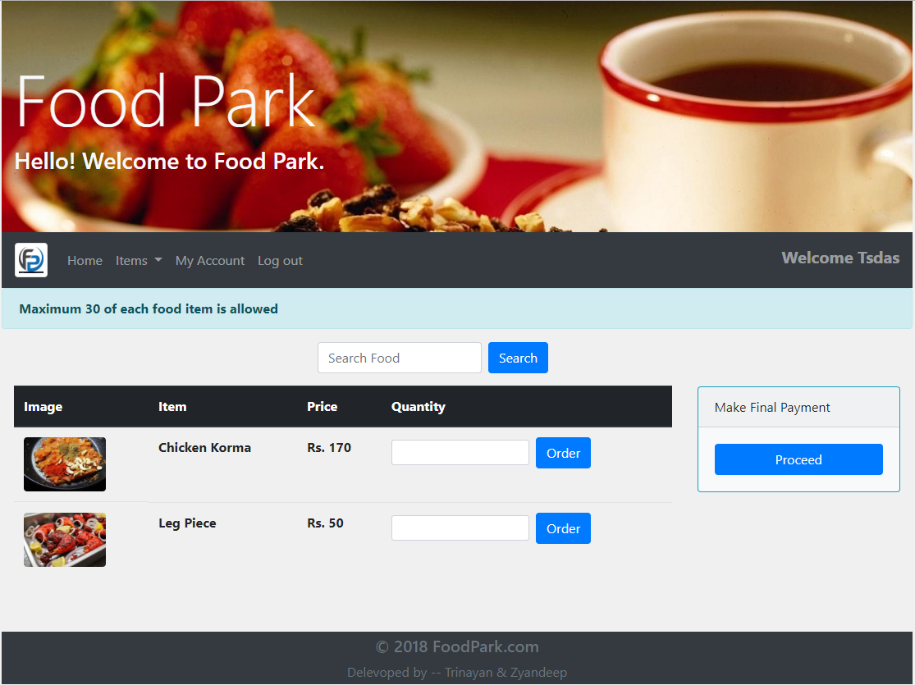

**Ordering Food Form**

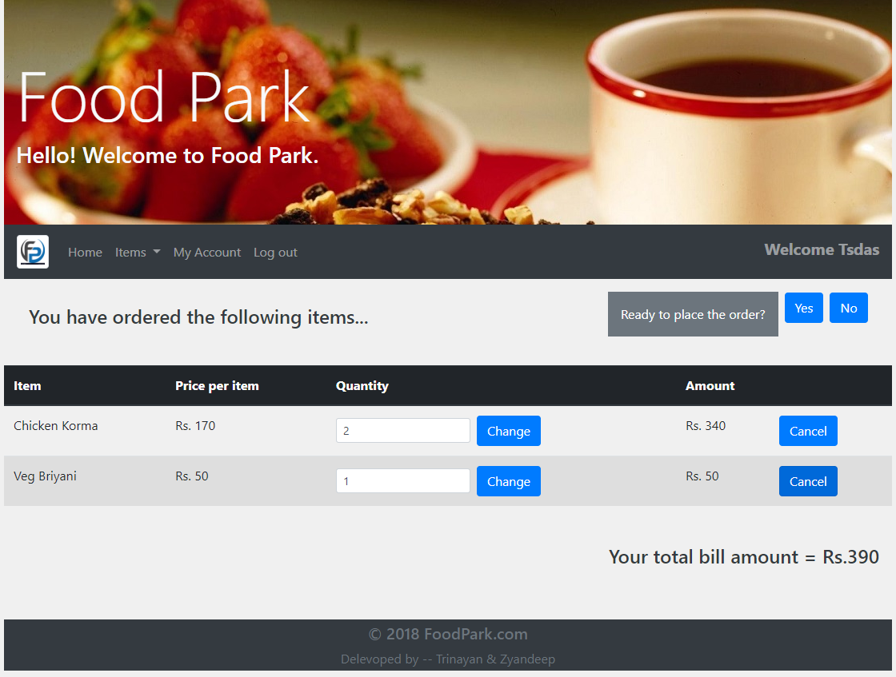

**Final Order Place Form**

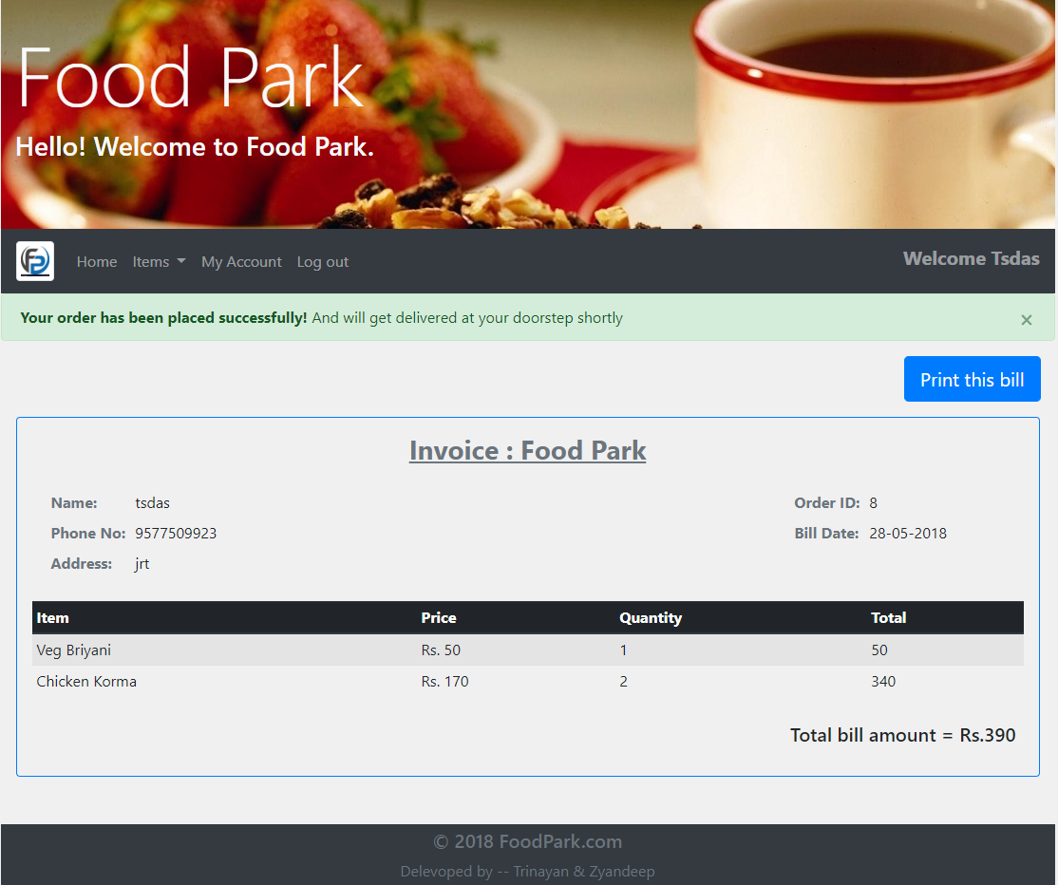

**Bill**

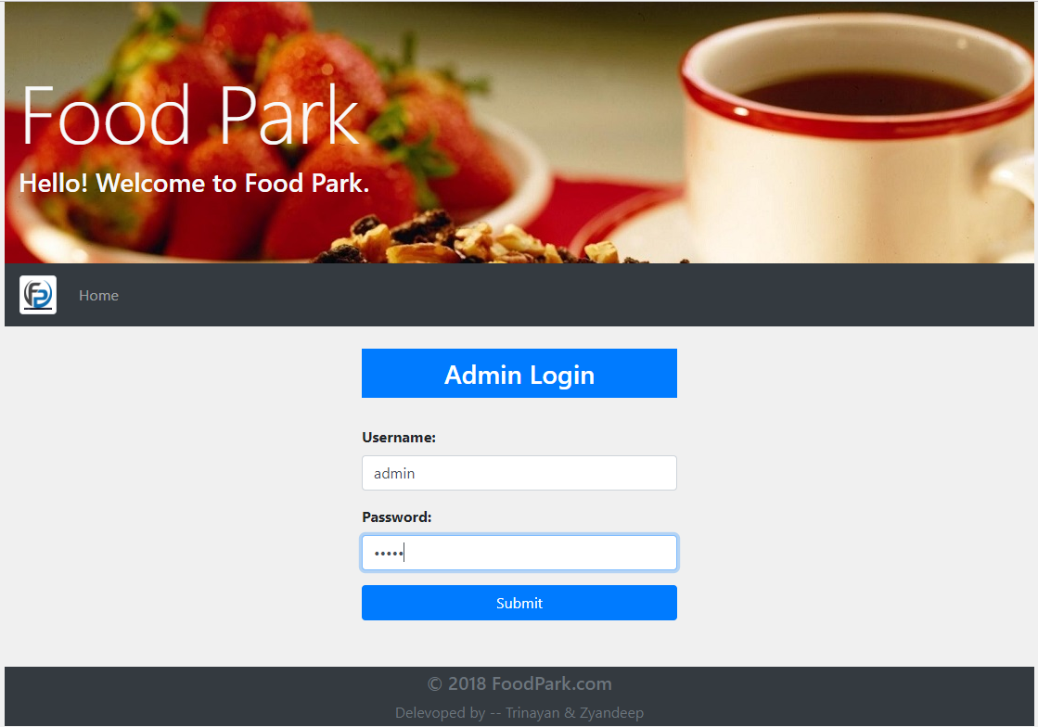

**Admin Login Form**

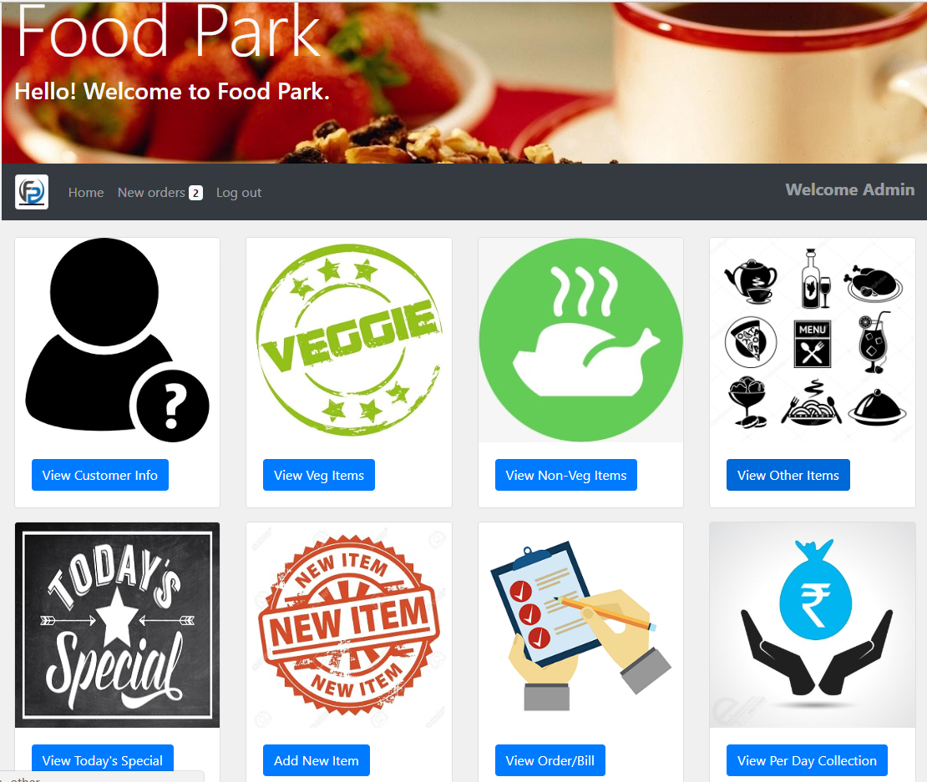

**Admin Home Page**

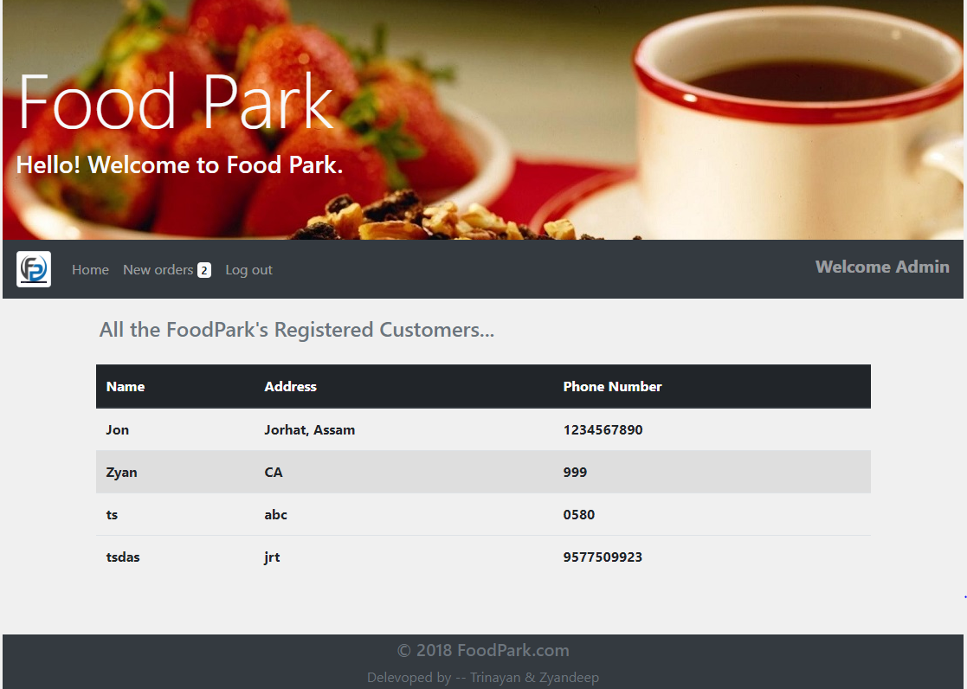

**View Customer Info by Admin**

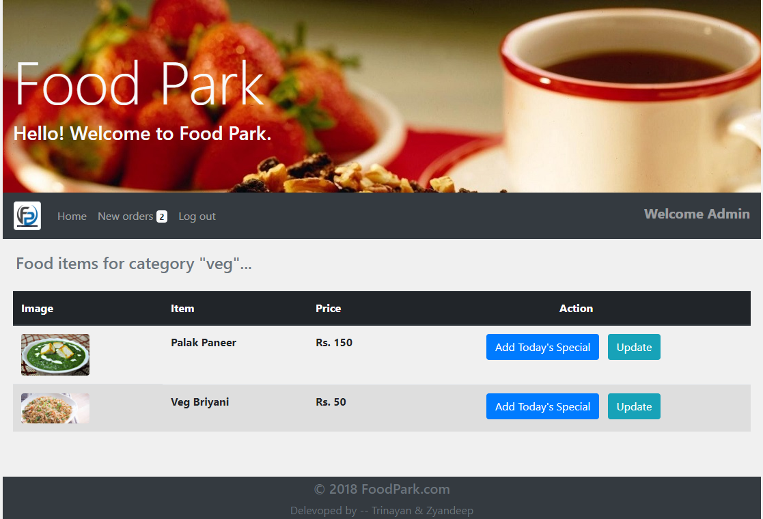

**View & Update Food Items by Admin**

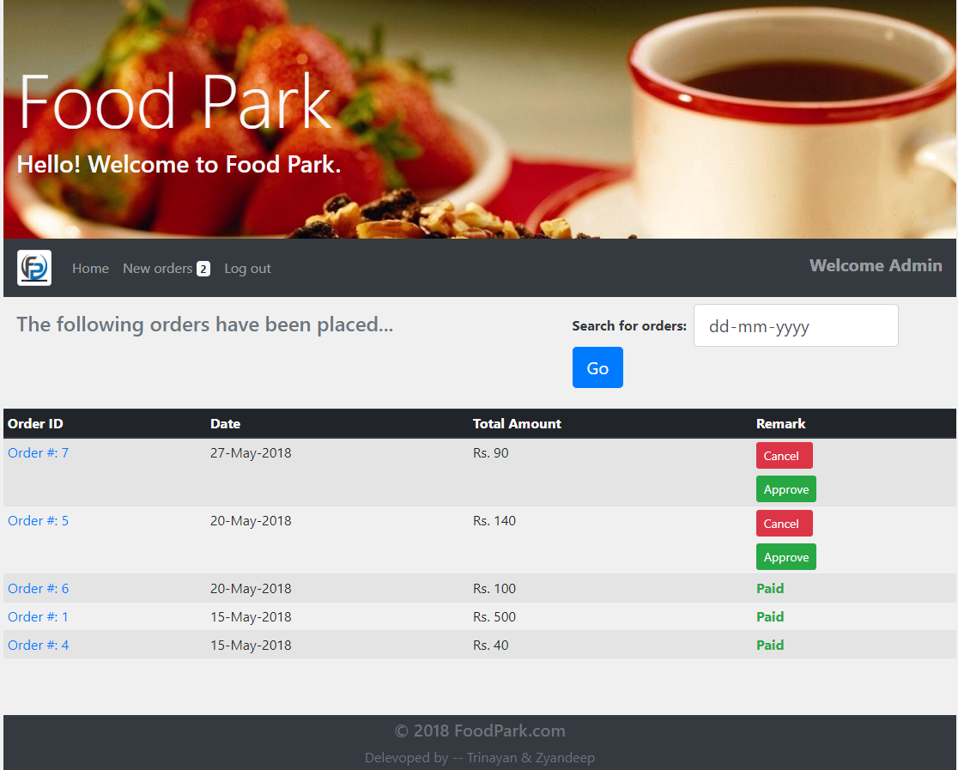

**Order Approved by Admin**

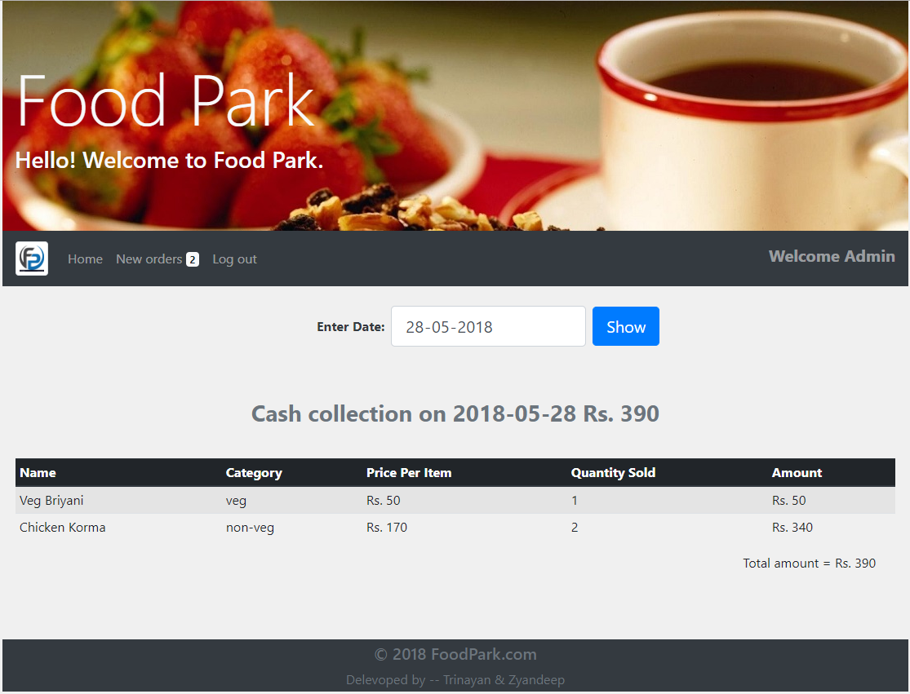

**Per Day Collection of items Viewed by Admin**

**CHAPTER 5: SCOPE AND CONCLUSION**

**5.1 SCOPE**

Software development is a never ending process and continues throughout the life cycle of the software. The software has been developed keeping in mind easy modification and enhancement that might be required from time to time. However, there may be some shortcoming due to our inexperience and lack of time.. The system was designed in the client/server model. After being lapsed, the system may be revived under certain condition, which is not covered in the system. As the necessity precipitates and further enhancement of the system becomes inevitable, the current system will serve as a building block for that system.

**5.2 CONCLUSION**

The “ONLINE FOOD DELIVERY SYSTEM” has been designed to allow users to order food items virtually. The system has been developed with much care that it is free of errors and at the same time it is efficient and less time consuming. The important thing is that the system is robust. Also provision is provided for future developments in the system.

**6 BIBLIOGRAPHY**

1. php.net
2. jquery.com
3. w3schools.com

ss